**The End of Jobs Summary**

*The End of Jobs explains why, thanks to the advancements of modern technology, being an entrepreneur is now the safest way to meaningful work and financial freedom.*

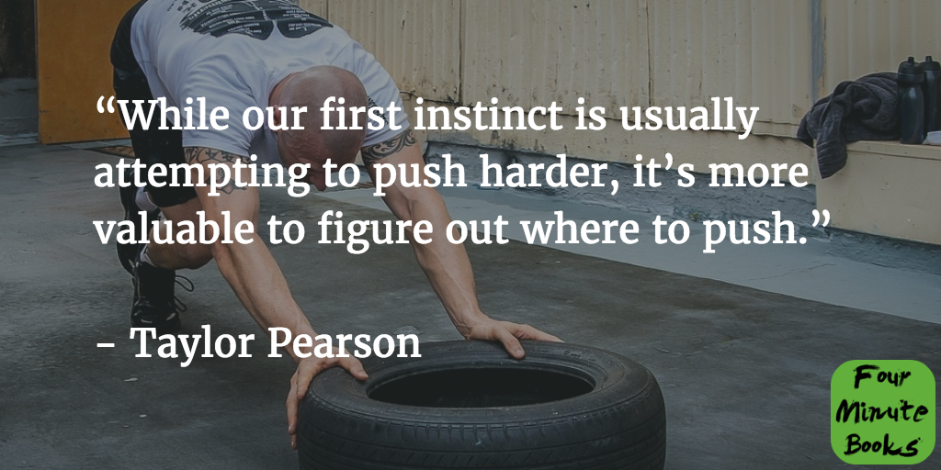

The book starts by taking a look at how we’ve reached the entrepreneurial boom we find ourselves in today.

Based on [Eli Goldratt’s](https://en.wikipedia.org/wiki/Eliyahu_M._Goldratt) [Theory of Constraints](https://en.wikipedia.org/wiki/Theory_of_Constraints), Taylor Pearson explains that the limiting factor in what we can achieve has switched multiple times throughout history, from land to capital to knowledge and now to **creativity**.

[Since 2000 the world’s population has grown 2.4 times faster than the supply of available jobs](http://www.kpcb.com/file/kpcb-internet-trends-2015), rendering the strategy to get a degree and thus a safe job, which worked so well for [baby boomers](https://en.wikipedia.org/wiki/Baby_boomers), useless.

College degrees have become much less valuable, due to the sheer amount of people who have them. From 2000 to 2010 alone [the number of college graduates in the US increased by 50% from 20% to 30% of the total population](https://en.wikipedia.org/wiki/Educational_attainment_in_the_United_States).

On top of that, modern technology, like Skype for worldwide video calls, makes it possible to hire the most talented people from anywhere in the world and **outsource knowledge tasks**.

Throw into the mix that you can now license software for most tasks to be done very cheaply, such as accounting, graphic design, video editing, and others and you have a world where anyone can start an international company right from the comfort of their home, no matter where they live.

Now starting a company still sounds dangerous to most people, but in an economy where lay-offs happen by the thousands on a regular basis, your job is no longer a safe bet either.

You have to stop relying on someone else to pay you every month, like an animal waiting to be fed, only to be led to the slaughterhouse one day, because you never know when your boss stops “feeding” you.

Instead, try to understand the concept of [expected value](https://www.youtube.com/watch?v=j__Kredt7vY), which is what lets poker players keep their cool.

They do a great job at calculating their probability of winning or losing any given hand, based on the cards on the table and in the deck, which is why they’re not worried about losing. A great poker player knows that if she makes a $10,000 bet with a 20% chance of winning $100,000 enough times, she will inevitably win, since her expected value is $20,000 each time she makes the bet.

That’s why you’re much better off learning new skills and dabbling in many little projects (such as the website you’re reading this summary on), which have huge potential upside and will inevitably work out well in the long run.

The worldwide availability of the internet has lowered production and distribution costs so much that you can create a product for any niche market you desire at almost no cost and distribute it for free or very cheaply.

If there’s a place for [dog trainers](https://www.cesarsway.com/), [accounting for dentists](http://dentistmetrics.com/) and [knitting](http://blog.tincanknits.com/), there sure is a need for whatever service or product you can offer to the world as well.

Even better, creating your own business will allow you to do work that is meaningful to you, which, if we’re honest, is the only way you can create a sustainable business anyway. Imagine not being forced to do tedious tasks on a daily basis, just so you can improve the quality of your life, but to actually find meaning in the work you do, helping others with what matters most to you.

Taylor Pearson also delivers a framework that’ll help you start your own business, one step at a time. According to [Rob Walling’s Stair Step Method](http://www.softwarebyrob.com/2015/03/26/the-stairstep-approach-to-bootstrapping/), you should create your career one step at a time, by first launching a simple one-off product, which you sell through only one marketing channel.

Then you can multiply this process until you don’t have to work to make a living any longer, and start creating bigger and bigger companies.

**Final thoughts**

I really liked these blinks. They confirm what James Altucher talks about in [Choose Yourself](http://fourminutebooks.com/choose-yourself-summary/) and The Rich Employee, and provide comfort for those who worry that they might not catch the entrepreneurship train before it’s gone.

I was reminded that I have time and I don’t need to have a successful business tomorrow, but that I should continue to explore my passions and follow these little side projects that I like so much.